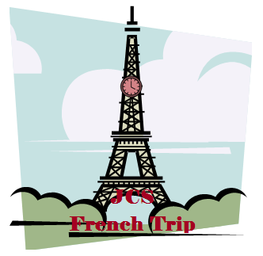
John Colet School
Wharf Road
Wendover
Buckinghamshire
HP22 6HF 01296 623348 office@johncolet.co.uk
John Colet School

Dear Parents or Carers
This year, we are planning an exciting French trip for our year 11 students. It will take place in October half-term, from Tuesday 15th January 2013 to Sunday 20th January 2013, a total of 5 days. We will set off at 7:30 am exactly. Any student not there will be left behind. We will then travel to Dover to catch 10:00 ferry to Dover from Calais. The ferry ride will cost £63 per student, and another £63 for the return trip.
When we arrive in Calais at approximately 11:30, we will travel another 3 hours and 30 minutes to Paris by minibus, where we will check into our hotel, Les Trois Poussins Hotel, and unpack. Once everyone has got settled, we will have lunch at the hotel, and spend the rest of the day doing our first sight-seeing activity, going to the Eiffel Tower. This will cost £44 per student and will last approximately 4 hours. We will then come back to the Hotel for dinner.
We will do a lot of sight-seeing activities throughout our stay, including visiting the Arc De Triomphe, Disney Land Paris, and other local attractions like the Le Bout theatre. We will also eat out at a few restaurants like the Sepharin restaurant. On the day of our departure, we will leave the hotel at 10:00 and set off for Calais. We will then catch the 2:00 ferry from Calais to Dover, and arrive at Dover at approximately 3:30; we will then drive home and arrive at about 6:00. Altogether, the trip will cost £567, but many parents might want to give their child spending money. We realise that this adds up to a lot, but it really is a fantastic opportunity for those year 11 students who are taking French, and also very educational, as everyone will be required to speak fluent French. There will be a meeting on Friday 19th October 2012 for more details on the trip, and there is also a check list on the next page. Please talk to me if you are unable to attend the meeting, and I will arrange a private meeting. Thank you.
Yours Sincerely

Isabelle Simpson
Head of MFL
Checklist:
Lots of Jumpers
Lots of T-shirts
Lots of Trousers/Jeans
Something smart for restaurants
A coat
Gloves
Hat
Socks
Sensible shoes e.g. trainers
Wash things e.g. toothbrush
Mobile Phone
Spending money
Camera
Something to entertain you for the way there and back
Notebook and pen
Medication for travelling
Packed lunch for trip to Paris
Small backpack to put everything in
Large suitcase for all of your clothes

Please DO NOT bring anything very valuable

